Year 3 – School Closure 25.06.2026
Creative activity | Reading activity | Science activity
- Design a dream ice cream shop and create a menu using the template.  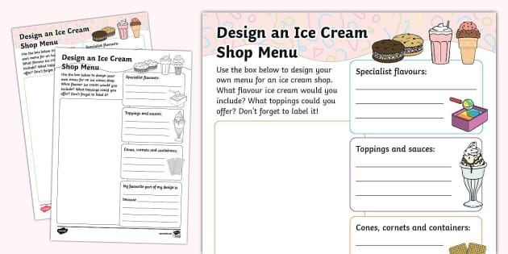 | - Read a book and complete a book review using the book review template.  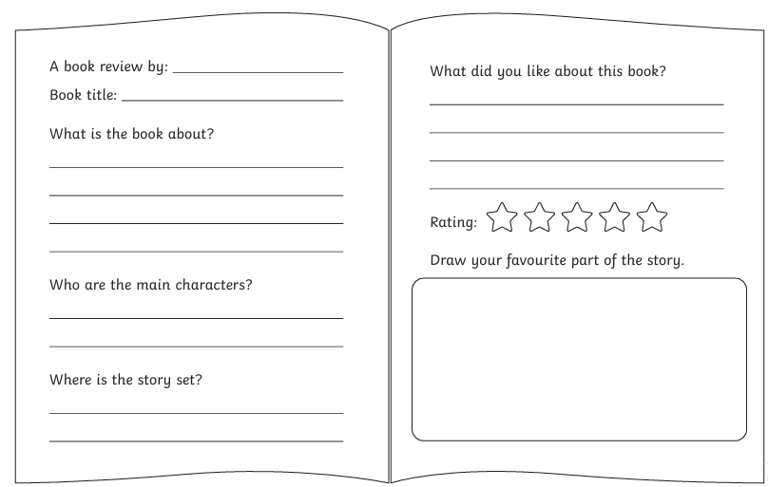 | - Do an experiment using a range of materials, to see which materials keep ice from melting longest!  

