
WMS Music Service Lessons Registration of Interest 2026-2027

*This form is for learners who do not currently take music service lessons with us.
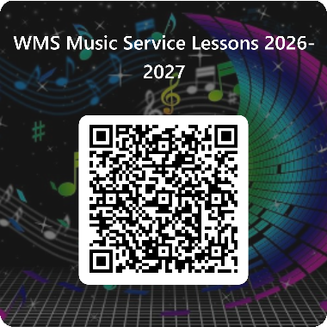
Please fill out this form to sign your child up for instrumental or vocal lessons at The Royal School Wolverhampton during the 2026-2027 academic year or complete the online form by scanning the QR Code.
We expect students to commit to take lessons for the whole year (we are happy to discuss changes of instrument if appropriate at any time). Lessons cost £52 per half-term/£312 per year per instrument. We divide this into the following payment schedule:
Autumn Term lessons: £52 payable 1st July 2026 + £52 payable 30th September 2026
Spring Term lessons: £52 payable 30th November 2026 + £52 payable 31st January 2027
Summer Term lessons: £52 payable 31st March 2027 + £52 payable 31st May 2027
The initial deposit of £52 must be made by 1st July to secure lessons for your child in September. If your child already learns an instrument with us and wishes to continue lessons, then please see separate correspondence on the School Gateway.
* Please complete all sections before submitting
1. What is your child's full name _______________________________________________________
2. Which year group will your child be in during the 2026-2027 academic year? Please note that lessons are only offered from Year 2 onwards.
Year 2 Year 3 Year 4 Year 5 Year 6
Year 7 Year 8 Year 9 Year 10 Year 11 Year 12 Year 13

3. Has your child received instrument lessons before?
No - my child wishes to start learning for the first time
Yes - my child has learnt an instrument at a different school
Yes - my child has had lessons at the Royal School
Other __________________________________________________________________________
4. If your child has received lessons before, which instrument/what level are they? (e.g. beginner, grade 1, etc.) ______________________________________________________________________
5. Which instrument/s would your child like to learn? Please be aware that some instruments may not be suitable for younger children due to the size and difficulty. Please select at most 2 options.
Woodwind: Flute Clarinet Recorder Saxophone Oboe Bassoon
Strings: Viola Violin Cello (from Year 5 onwards)
Guitar: Acoustic Guitar Bass Guitar Electric Guitar
Brass: Trumpet Trombone French Horn Tenor Horn Euphonium Tuba
Singing: Vocal
Piano: Piano Keyboard
Drum: Drum Kit
Dhol: Dhol (from Year 4 onwards)

6. What is your parental email address? ________________________________________________________
7. Please tick 'yes' if your child wishes to take music lessons after experiencing whole class instrument teaching in Year 3? Yes No
8. Please tick 'yes' to confirm you understand that Music Lessons are offered at a cost of £312 per year, payable as per our payment schedule in advance of half term. Cancellations will only be accepted to be effective from the end of term (Christmas, Easter, Summer) and require a half term notice in writing by email to kcooper@theroyal.school. All arrears will need to be paid in full and any instrument on loan must be returned. Yes No

9. Progress Reports
- A progress report will be issued by Wolverhampton Music Service during the year.

10. Ensemble Participation
- Students receiving tuition may be expected to join relevant School ensembles and participate in rehearsals and performances.

11. Years 11, 12 & 13
- Parents/carers must ensure students attend lessons during study leave and after exams until the end of the School year.

Parent/Carer Agreement
I agree that:
- I have read and accepted all terms and conditions stated above.
- I will support my child’s musical development, including ensuring regular practice and providing necessary materials.
- My child will catch up on any classwork missed due to music lessons.
- I accept responsibility for any instrument loaned from the School or Wolverhampton Music Service and will ensure it is covered on my home insurance.
- I will pay all fees as required.
- If fees are unpaid, I understand that lessons will be cancelled until any outstanding balance is paid in full.
Parent Name: __________________________________________________________________
Parent Phone Number: ___________________________________________________________
Please submit the completed form to kcooper@theroyal.school

