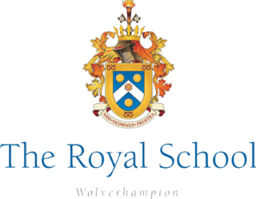
The Royal School Wolverhampton: WMS Music Tuition Contract 2026-2027
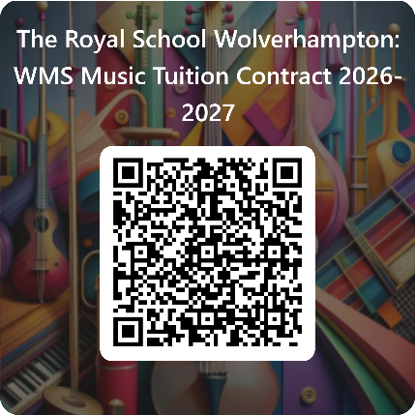
The Royal School undertakes to provide Music Tuition to the above student during the academic year September 2026 to 2027. This is in partnership with the Wolverhampton Music Service (WMS).
Please read the following terms and conditions before signing and submitting your agreement. Alternatively, the form can be submitted online by scanning the QR code.

Payment
- Payment will be £52 per half term/£312 per year (per instrument), covering both instrumental lessons and instrument rental (where possible). Payments will be divided into the following payment schedule (to be paid in advance of each half term). All payments will be made on the School Gateway and must be made in advance of lessons starting each term.
- Autumn: 1st July 2026 £52 + 30th September 2026 £52
- Spring: 30th November 2026 £52 + 31st January 2027 £52
- Summer: 31st March 2027 £52 + 31st May 2027 £52
The initial payment of £52 must be paid by 1st July to secure lessons for September 2026.The cost of Music Service lessons is heavily subsidised by the Royal School. Students should expect to receive 30 lessons (minimum) across the year. The Music Service teachers will be in school for 33 weeks of the school year. This allows for 'catch-up' time for any lessons missed due to teacher absence or school trips. Therefore, any reimbursement for missed lessons will not be possible, unless in extreme circumstances. Any student showing arrears at 1st July 2026 for the current academic year will not be entered into the Music Lesson Registers for September.
Attendance
· The school/service will ensure that your child receives a minimum of 30 paired or small group lessons per academic year.
· Arrangements will be made where possible to catch up with any lessons missed due to unforeseen circumstances (eg: school closure or teacher absence). However, lessons missed due to forgetfulness or school trips cannot be made up. It is the responsibility of the student (senior school) to check timetables, liaise with their teacher and attend their lesson.
· It is the responsibility of the student to catch up on any work missed in classroom lessons.
· Your child will be invited to attend one of the many instrumental ensembles run by the Wolverhampton Music Service outside of school.

Instruments
· It is the responsibility of the student to care for their loaned instrument carefully and as instructed by their teacher. Any borrowed instrument must be returned to school in a good condition at the termination of this agreement. Any instrument left unattended is done so at the student’s own risk.
· It is the responsibility of the student to bring the appropriate instrument and other materials to the lesson as required by their teacher.

Assessment and Progress
· The Music Service will provide an annual progress report on your child’s musical development and a practice diary where you can monitor your son/daughter’s progress on a weekly basis. You will be able to contact your child's music teacher by email for further progress updates.
· The Music Service will determine when your child is ready to take an exam in their instrument. This is not compulsory and is subject to an additional exam fee where you wish your child to do so.

Continuation and Cancellation
· Parents will be required to sign a new contract prior to each new academic year as their child continues lessons.
· Cancellation of lessons during this contract period will only be allowed at Christmas or Easter and will require a full half term’s notice. Parents will need to cancel lessons by email to kcooper@theroyal.school and ensure all fees are paid to the end of that term. Should your son/daughter stop attending lessons at any other time or without notice you will still be charged the full term’s payment for these lessons as this incurs a cost for the school. Students in Years 11, 12 and 13 are expected to continue to attend music lessons during study leave and after exams until the end of the School year.
· Payment schedules must be adhered to. In the event of non-payment, your child will not be able to continue their music lessons and will be required to return the loaned instrument.
Agreement
Please complete the below agreements to confirm you have read and understood the Music Contract.
We hope that you enjoy your music lessons this year!
If you have any questions at any time please contact Mrs Simmonds, Director of Music, or Mrs Cooper, Performing Arts Administrator (kcooper@theroyal.school)

- Child's Full Name___________________________________________________

- Child's Year Group (2026-2027)
Year 2 Year 3 Year 4 Year 5 Year 6
Year 7 Year 8 Year 9 Year 10 Year 11 Year 12 Year 13

- Which musical instrument/s do you wish to learn/continue with?
___________________________________________________________________

- I, the parent or guardian of the above named child, agree to the above contract and the terms and conditions as stated. I wish for my child to receive instrumental or vocal tuition in partnership with The Royal School and the Wolverhampton Music Service during the academic year September 2026 to July 2027. I understand that payments should be made promptly in line with the payment schedule outlined above. Yes No
5. Parent Full Name: ______________________________________________________

6. Parental Email: _______________________________________________________

7. I, student in question, agree to attend my lessons, practice at home and look after my borrowed instrument. Yes No

8. Date of Agreement: _____________________________________

Please submit the completed contract form to kcooper:theroyal.school

