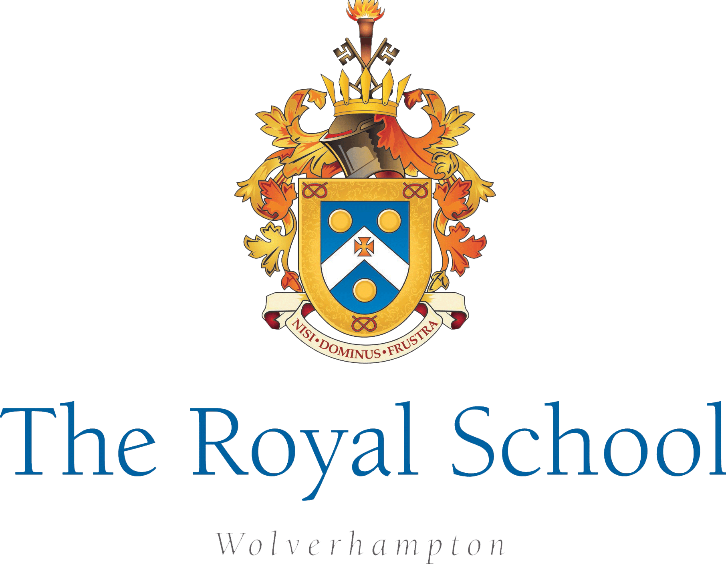

12th May 2026

Dear Parents and Carers,

We are pleased to let you know that Year 1 will be visiting the Black Country Living Museum on Tuesday 23rd June. This exciting trip will give the children the opportunity to explore the museum and learn more about life in the past.

As part of the visit, the children will explore a range of historical structures and learn about how buildings and everyday life have changed over time.

The cost of the trip is £10.85, which should be paid via School Gateway.

The children will travel by coach and will leave and return within the normal school day, depending on traffic conditions. Pupils should come to school wearing their PE kit and bring a waterproof coat in case of wet weather or a sun hat if the weather is warm.

Children will need a packed lunch for the day, which can be provided by school if required. If you prefer to send a packed lunch from home, please ensure that all items are nut free and follow our healthy eating policy (no sweets or chocolate items).

Please also provide your child with a bottle of water. As the children will be carrying their own belongings, please ensure they bring a suitable bag for their lunch and coat.

Thank you for your continued support.

Kind regards,
Miss Smith
Year 1/2 Phase Lead

