
The Royal News
The Royal News

Friday 26th January 2024

As we reflect on the past week, it is clear that our pupils have been deeply engaged in activities centred around personal development and safety. It has been an inspiring and enlightening time for all, filled with meaningful discussions and hands-on experiences.

This week, Eva Abley graced Year 4 with her empowering presence once again, sharing her remarkable journey. The children were captivated by her story, highlighting the importance of perseverance and resilience in the face of challenges. The focus extended to the discussion of disabilities, emphasising inclusivity and creating a welcoming environment for everyone. Our pupils have embraced the idea of making sure every individual feels safe and valued, reinforcing the sense of community within our school.

Safety took centre stage in Year 5 as pupils embarked on a visit to Safeside. In this immersive experience, they delved into the concept of risk and learned how to take safe risks. Navigating through a simulated hazardous house, the children identified key factors that could compromise their safety. Additionally, they practised caution and awareness while crossing the road, instilling valuable life skills. The exemplary behaviour of our pupils showcased the embodiment of school values and left a positive impression on all.

Throughout the school, every year group engaged in circle times, focusing on the school's core learning behaviours. These behaviours are essential pillars that contribute to the holistic development of our pupils:

Trust - empathiser, independence, self-motivation
Respect - listener, includer, positivity
Initiative - reflector, proactive, adapter
Community - collaborator, communicator, tolerance
Risk - explorer, achiever, resilience

These circle times provided a platform for open discussions, allowing children to explore and express their feelings. Pupils learned how to handle their emotions, understand the feelings of others, and cultivate kindness towards their peers. Year 5 delved into the emotions iceberg, recognising that what we see on the surface may not reflect the deeper emotions hidden beneath.

As we look ahead to the coming week, we are excited to witness the ripple effect of kindness and understanding that has been sown among our pupils. Let's continue to foster a safe and supportive environment where each child can thrive.

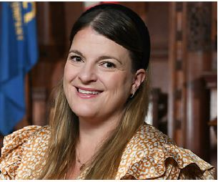

Mrs S Holdsworth
Assistant Head
Careers & Transitions




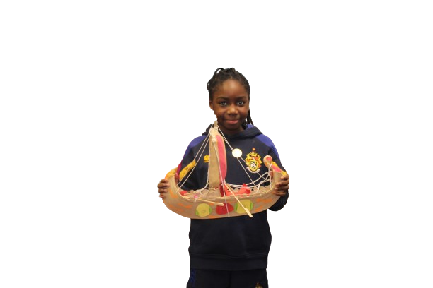

Afua 4LD came to visit Mrs Jefferson with her amazing homework from Year 4’s topic on Vikings. Well done!


National Story Telling Week.

In assembly this week Mrs Bates read the story of Cinderella and explored with the pupils how there are different versions of the story from all around the world.



Please click HERE for further stories

A S S E M B L Y

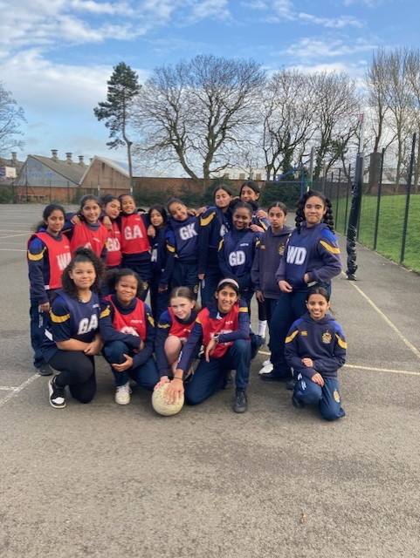
Sporting Fixtures

- Wednesday 31st January - U10 -U11 Netball v Old Hall (H)

- Monday 29th January – Yr 1 to Year 6 Author Workshop
- Wednesday 31st January – Reception visit to Planetarium
- Wednesday 31st January – Yr 4 Junior PCSO
- Wednesday 31st January – Parents Evening (On-Line)

Year 6 Netball v Yarlet

Year 6 teams played netball against Yarlet School on Wednesday 24th January. We narrowly lost both matches but had a great time and worked well as a team. Both teams worked with our Year 11 coaches. Players of the match were Milan and Anisha, well done everyone!

Diary

Housepoints

Balmoral | 1830
Sandringham | 1505
Buckingham | 1605
Windsor | 1590




https://www.yowolves.co.uk/events

Attendance Week Commencing Monday 22nd January 2024

Central Community Shop in the historic Queens’ building in Wolverhampton City Centre, is the result of a partnership between the Good Shepherd, City of Wolverhampton Council and Wolves Foundation.
The Good Shepherd will co-ordinate the running of the shop, offering a dignified experience for people to buy items at affordable prices.
The Good Shepherd’s involvement at the Central Community Shop will be in addition to continuing to offer free-to-access food and support services from our premises on Waterloo Road.
The idea is for the shop to be a sign of both progression and prevention when so many people are going through such challenging times.
Anyone who is a resident of Wolverhampton can access the shop once they have paid an annual membership fee of £3.

Please click HERE for the official website


Donations Required
We are seeking your generous contributions for our Community Food Project. Donations can be dropped off at Reception, or in Year 5 & Year 6 classrooms.
WC 29th January 2024 | Pasta, rice, tinned potatoes/Smash, cereal, baked beans, spaghetti, pasta sauce
WC 5th February 2024 | Tinned meat/meals (eg curry or chilli), canned fish, pasta sauce, tinned sweetcorn, tinned carrots/peas
WC 19th February 2024 | Jam, honey, tinned puddings, tinned custard, biscuits, chocolate and other treats.
WC 25th February 2024 | Tea, coffee, UHT milk, sugar, squash, juice (non-refrigerated).

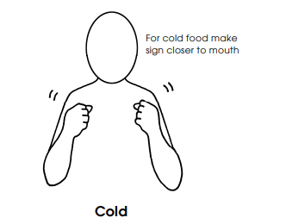


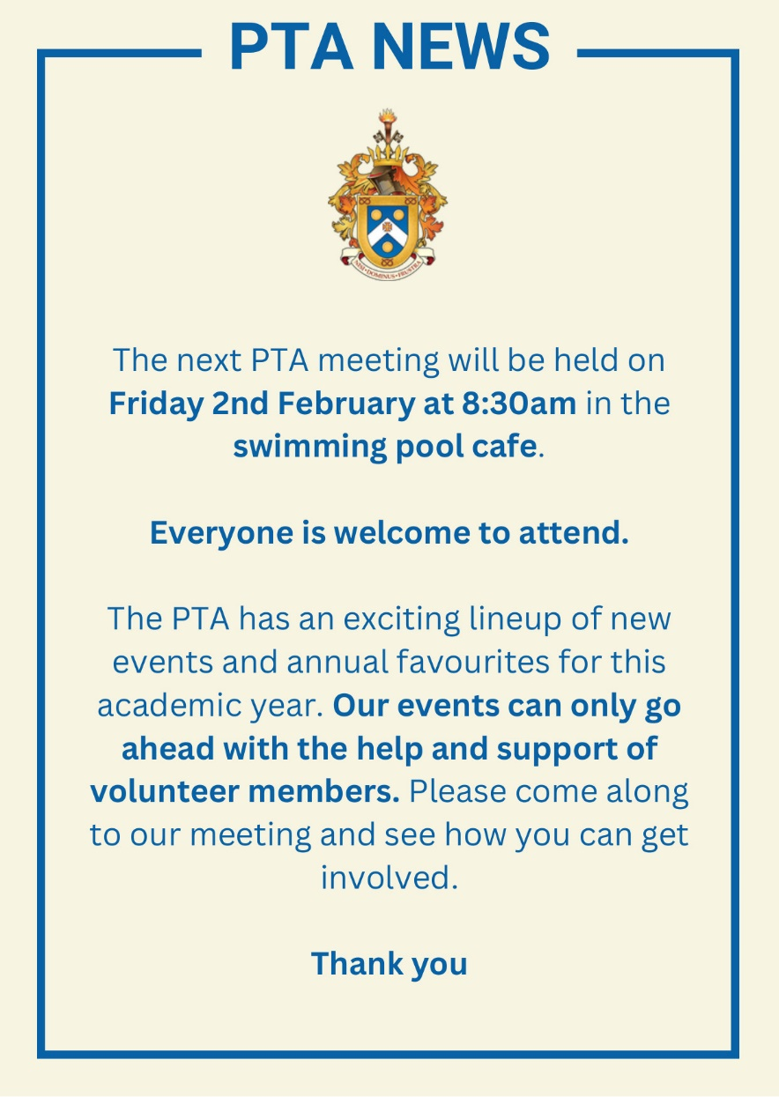

Donations Required
We are seeking your generous contributions for our Community Food Project. Donations can be dropped off at Reception, or in Year 5 & Year 6 classrooms.
WC 29th January 2024 | Pasta, rice, tinned potatoes/Smash, cereal, baked beans, spaghetti, pasta sauce
WC 5th February 2024 | Tinned meat/meals (eg curry or chilli), canned fish, pasta sauce, tinned sweetcorn, tinned carrots/peas
WC 19th February 2024 | Jam, honey, tinned puddings, tinned custard, biscuits, chocolate and other treats.
WC 25th February 2024 | Tea, coffee, UHT milk, sugar, squash, juice (non-refrigerated).

Year 3 & Year 4 Visiting Storyteller

This week, Year 3 and 4 had a visit from Mr Peter Chand, who is one of Europe's most renowned storytellers. He shared his evocative and powerful stories from the Indian subcontinent with the students and also gave them the chance to share their own stories with him and work on the structures of their upcoming writing pieces. The children had great fun!

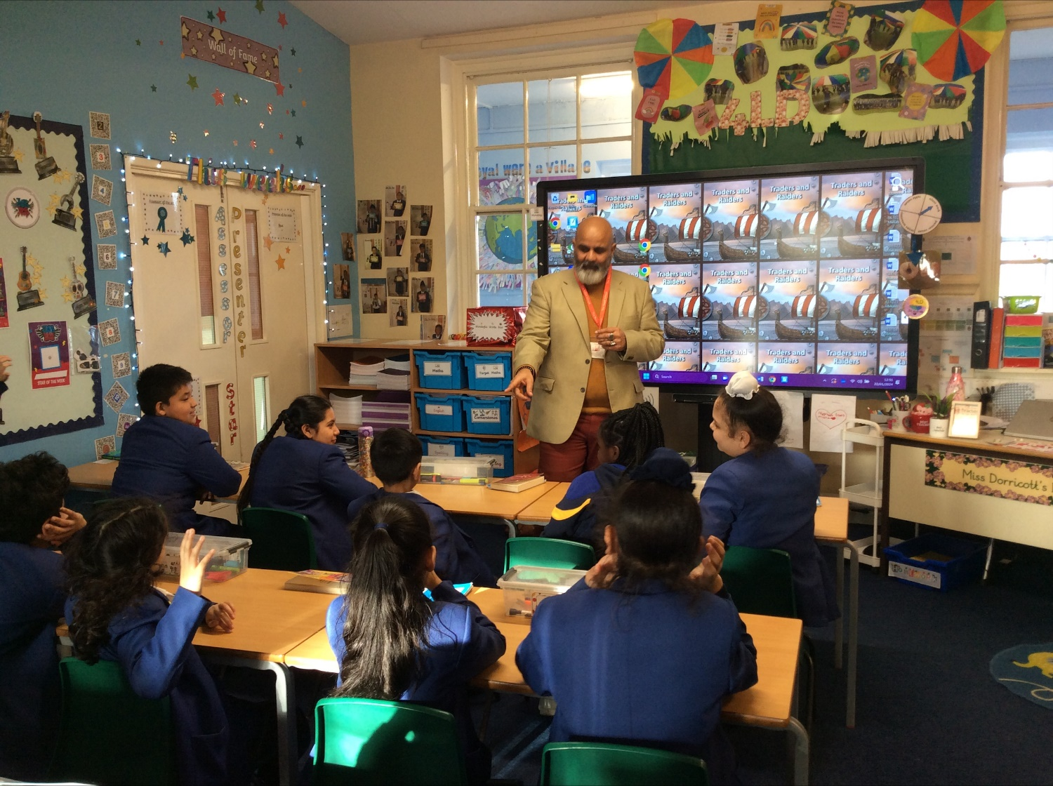


Vaccination UK have been instructed by NHSE to administer the MMR vaccination to all school aged children who are outstanding one or both doses.

The MMR would have been given at the age of 1 year and the second dose at 3 years and 4 months. There has been an outbreak of Measles in the West Midlands which have been on the rise within the last few weeks. If your child is outstanding one or both doses of the MMR, please contact their office on 01902 200077 to make an appointment. This will be at an alternative venue and NOT at the school.

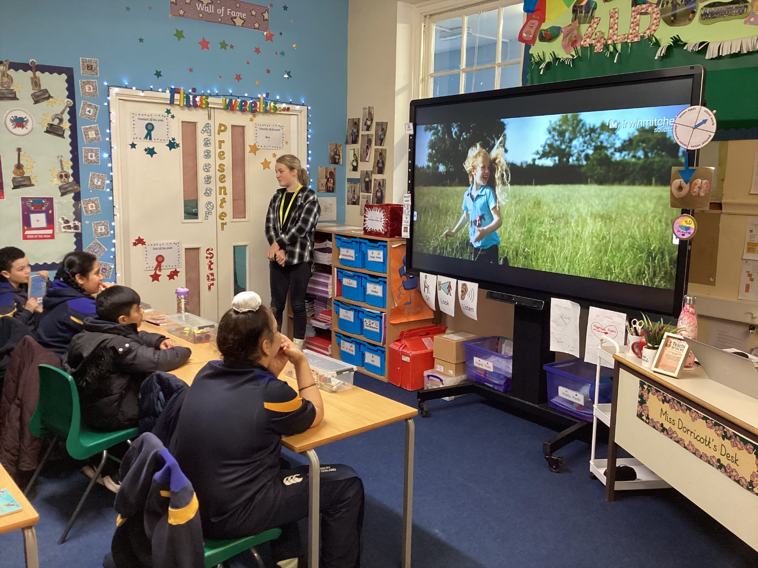
On Thursday this week, Year 4 had a visit from Eva Abley. For those of you who aren't aware, Eva was a 2022 Britain's Got Talent finalist and is a young comedian.

She delivered a presentation to the students regarding her own disability and raised awareness of how to be an inclusive learner. She is such an inspiration, and the students were in awe of her achievements.

Message from Finance Department
Outstanding meal charges

You will see that we are moving our Catering services to Accent Catering from 1 February and we need your help. Can you please ensure that you clear any outstanding meal charges by Wednesday 31 January and top up your child's meal account to ensure they can access the catering service facility. If you do not have sufficient funds on your child's account, they will need to bring a packed lunch from Thursday 1 February.

Mrs J Phillips
Director of Finance and Services



